University of Azad Jammu & Kashmir Muzaffarabad



Name | Syed Muhammad Hassan Gillani
Roll No. | 2024-SE-42
Instructor Name | Engr.
Course Title | Operating System
Semester | 3rdSemester
Assignment No | 01
Submission Date | 2025-10-30

Department of Software Engineering

1. Network Requirements Analysis

1.1 Scenario
A newly established educational institute requires a small computer network connecting its administration and academic departments. The network should provide reliable communication, logical separation of departments, straightforward management, and sufficient capacity for future expansion.

1.2 Estimated Devices
Department / Area | PCs | Other Devices | Total Estimated
Administration | 8 | 1 network printer | 9
Faculty / Academic | 12 | 1 network printer | 13
IT / Lab | 20 | 1 server | 21
Network Infrastructure | — | 3 switches + 1 router | 4

The design therefore provides connectivity for approximately 47 endpoint/infrastructure devices. The exact device count is an assumed design value for this open-ended scenario and should be adjusted if your instructor expects a different institute size.

TASK 1 — Network Requirements Verification
For the packet tracer implementation, the network is designed as:
Switches corresponding to the departments.
- Administration
- Academic
- IT/Lab
Each with 3 PCs initially.
So one router, 3 switches and 9 PCs (3 for each switch) result in a total of 13 devices.
This allows departments to communicate through the router while keeping their networks logically separated. It’s a scaled implementation of the proposed institute network.

2. Topology Selection and Justification
A hierarchical star topology is selected. Each department connects its end devices to an access switch, and the departmental switches connect toward a central Layer-3 routing point. This arrangement is suitable for a small institute because individual links can be isolated for troubleshooting, expansion can be made by adding ports or switches, and the logical departmental networks can be separated using different IP subnets.
The design uses three access switches: one for Administration, one for Faculty/Academic users, and one for the IT/Lab area. A router provides inter-network routing between the departmental subnets.

TASK 2 — Topology Evidence
Star-based topology connecting the three departmental networks:

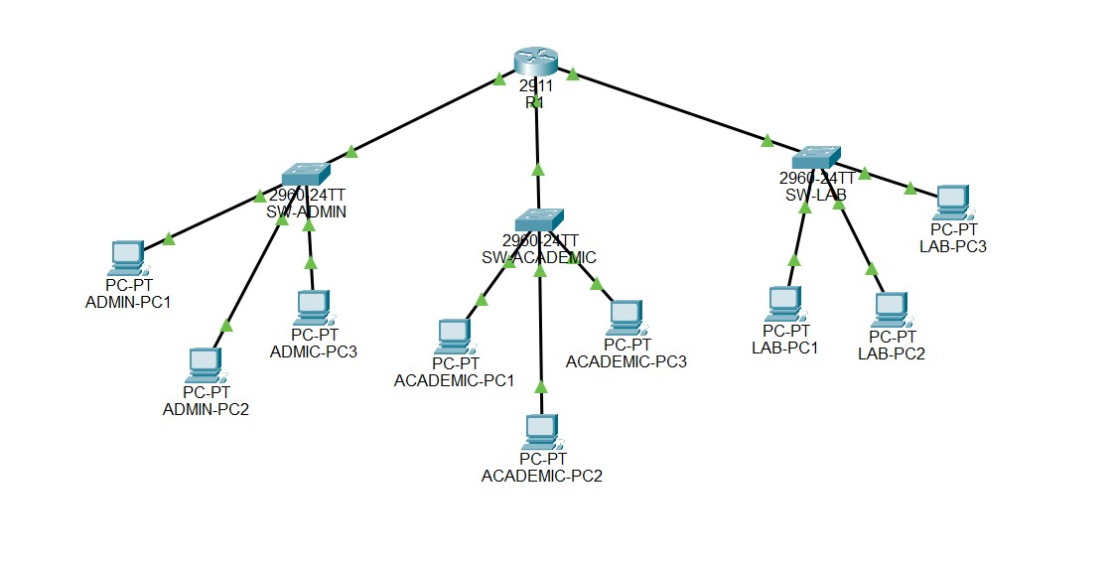

3. Network Cabling Plan
Connection | Recommended Cable | Reason | Typical Use
PC ↔ Switch | Copper straight-through, Cat6 | Reliable Ethernet connection and good bandwidth | End devices
Printer/Server ↔ Switch | Copper straight-through, Cat6 | Standard Ethernet connection | Network resources
Switch ↔ Router | Copper straight-through, Cat6 | Ethernet uplink to routing device | Inter-network connectivity

Cat6 copper Ethernet cabling is recommended for the proposed small network because it supports common Gigabit Ethernet deployments, is practical for short indoor runs, and is easy to terminate and troubleshoot. Fiber can be considered later if the institute expands to longer distances or requires higher-capacity uplinks.

Cabling Implementation
In Packet Tracer, we make the physical connections and record the cable type used for every link, clear from topology diagrams.

4. Switch Design and Configuration
Three access switches are used. Each switch serves one logical department. The following port allocation is a practical example and can be changed according to the number of end devices used.
Switch | Department | Example Access Ports | Uplink
SW-ADMIN | Administration | Fa0/1–Fa0/8 | Fa0/24 → Router
SW-ACADEMIC | Faculty / Academic | Fa0/1–Fa0/12 | Fa0/24 → Router
SW-LAB | IT / Lab | Fa0/1–Fa0/20 | Fa0/24 → Router

Basic Switch Configuration Template
Use the following commands as a starting point. Device names and interface numbers should match your Packet Tracer topology.
enable configure terminal hostname SW-ADMIN no ip domain-lookup enable secret class line console 0 password cisco login exit interface range fa0/1-8 switchport mode access no shutdown exit interface fa0/24 no shutdown exit end
copy running-config startup-config
Repeat the configuration for SW-ACADEMIC and SW-LAB, changing the hostname and access-port range as needed. If your instructor requires VLAN configuration, VLANs can be added as an extension; the base task mainly requires logical switch design and basic configuration.

TASK 4 — Switch Configuration and Verification
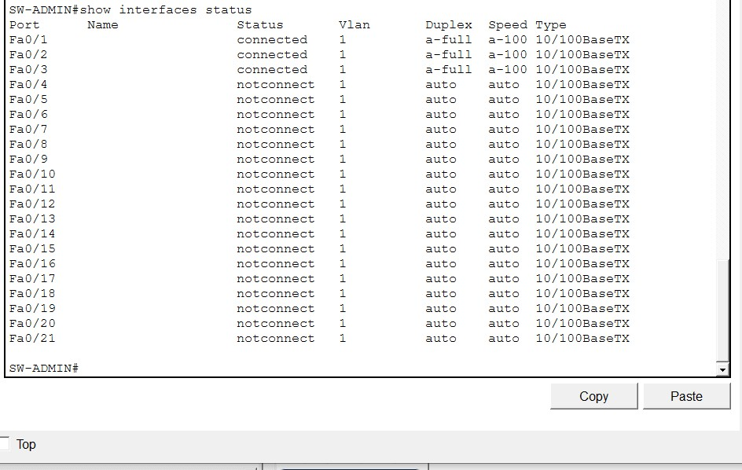
SW
-
ADMIN

SW-ACADEMIC

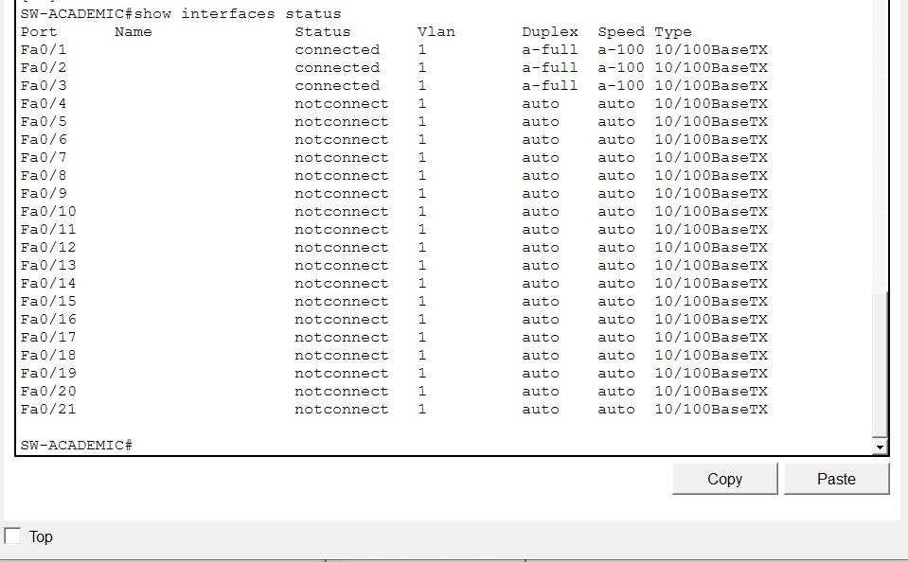

SW
-
LAB

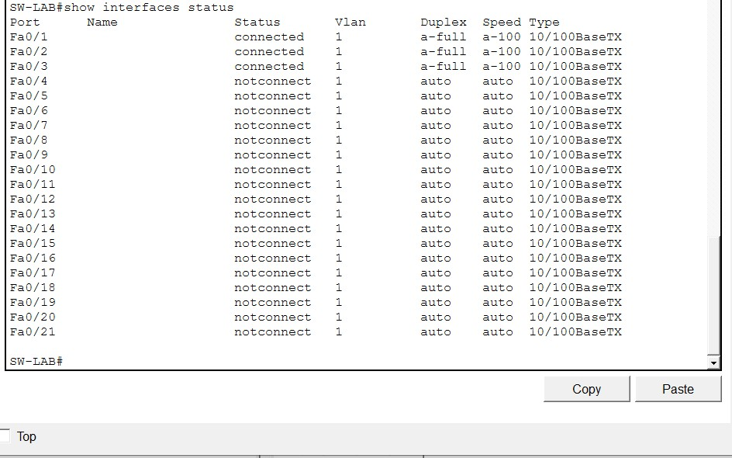

5. Router Configuration and IP Addressing
A separate IPv4 subnet is assigned to each department. This provides logical separation while allowing the router to provide communication between the segments. The /24 networks are simple to understand and leave substantial room for future devices.
Device/Interface | IP Address | Mask | Purpose
R1 G0/0 | 192.168.10.1 | 255.255.255.0 | Administration gateway
R1 G0/1 | 192.168.20.1 | 255.255.255.0 | Academic gateway
R1 G0/2 192.168.30.1 255.255.255.0 Lab gateway

Device | IP | Mask | Gateway
ADMIN-PC1 | 192.168.10.10 | 255.255.255.0 | 192.168.10.1
ADMIN-PC2 | 192.168.10.11 | 255.255.255.0 | 192.168.10.1
ADMIN-PC3 | 192.168.10.12 | 255.255.255.0 | 192.168.10.1
ACADEMIC-PC1 | 192.168.20.10 | 255.255.255.0 | 192.168.20.1
ACADEMIC-PC2 | 192.168.20.11 | 255.255.255.0 | 192.168.20.1
ACADEMIC-PC3 | 192.168.20.12 | 255.255.255.0 | 192.168.20.1
LAB-PC1 | 192.168.30.10 | 255.255.255.0 | 192.168.30.1
LAB-PC2 | 192.168.30.11 | 255.255.255.0 | 192.168.30.1
LAB-PC3 | 192.168.30.12 | 255.255.255.0 | 192.168.30.1

Segment | Network | Gateway | Usable Host Range | Broadcast
Administration | 192.168.10.0/24 | 192.168.10.1 | 192.168.10.2–  192.168.10.254 | 192.168.10.255
Academic | 192.168.20.0/24 | 192.168.20.1 | 192.168.20.2–  192.168.20.254 | 192.168.20.255
IT / Lab | 192.168.30.0/24 | 192.168.30.1 | 192.168.30.2–  192.168.30.254 | 192.168.30.255

Router-on-a-Stick Example Configuration
If one physical router interface is connected to a switch trunk, router subinterfaces can represent the three departmental networks. This example assumes the router interface connected to the switching infrastructure is GigabitEthernet0/0.
enable configure terminal hostname R1
interface gigabitEthernet0/0 no shutdown exit interface gigabitEthernet0/0.10 encapsulation dot1Q 10 ip address 192.168.10.1 255.255.255.0 exit interface gigabitEthernet0/0.20 encapsulation dot1Q 20 ip address 192.168.20.1 255.255.255.0 exit interface gigabitEthernet0/0.30 encapsulation dot1Q 30 ip address 192.168.30.1 255.255.255.0 exit end
copy running-config startup-config
Because this configuration uses 802.1Q subinterfaces, the switch uplink connected to the router must be configured appropriately as a trunk, and the relevant VLANs must exist. If your lab topology instead uses separate physical router interfaces, configure each interface directly with the corresponding gateway address.

STUDENT TASK 5 — Router Configuration and Connectivity

Using IP Addressing table above:

R1 interface configuration and status:
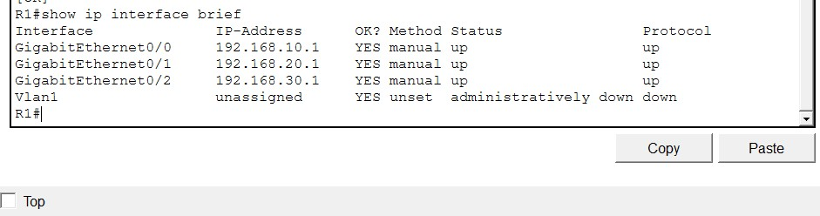

Connectivity Testing between departmental networks

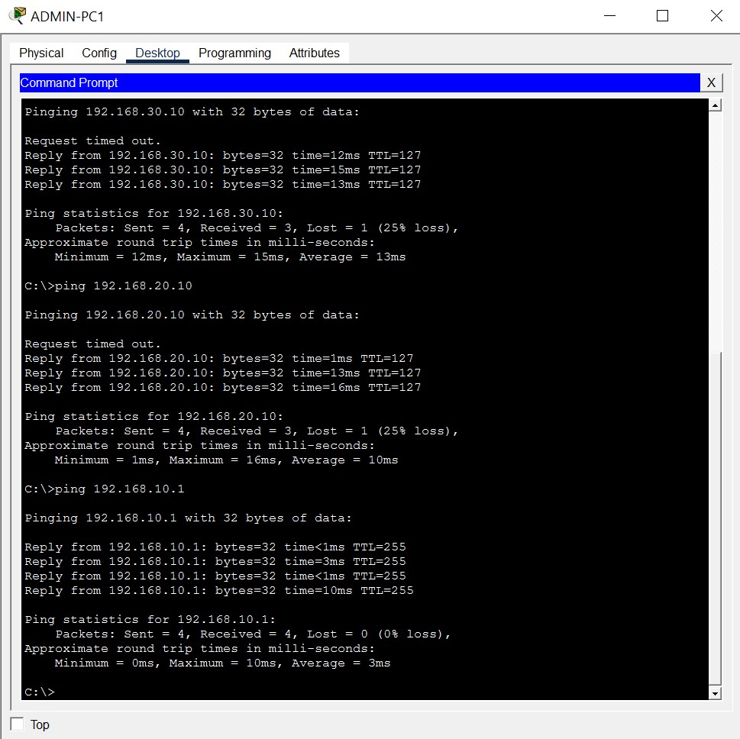

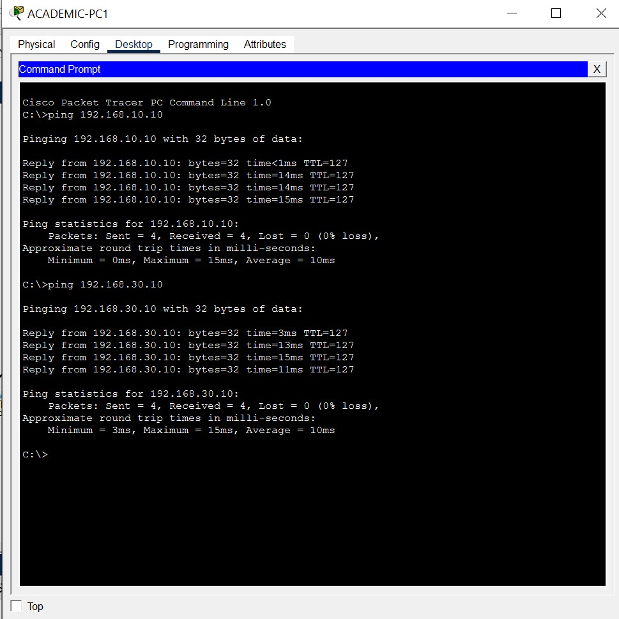

Successful inter-network connectivity testing using ping

6. Complete Logical Network Diagram

TASK 6 — Complete Logical Network Diagram
Final Network Diagram

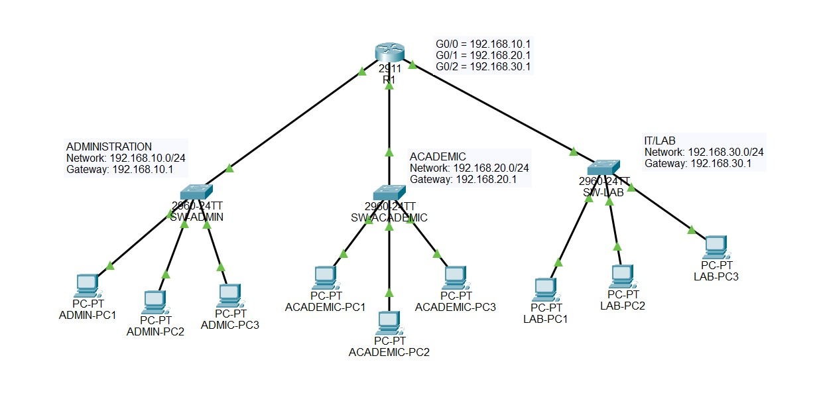

7. Future Improvements
- VLAN-based segmentation and inter-VLAN security policies can be expanded to isolate departments and reduce unnecessary broadcast traffic.
- Wireless access points can be added to provide managed Wi-Fi for students, faculty, and staff, with separate SSIDs and security policies.
- A firewall or dedicated security appliance can be introduced between the internal network and the Internet to improve perimeter security.
- Redundant switches, links, or routing equipment can be considered to improve availability as the institute grows.
- Centralized services such as DHCP, DNS, directory services, monitoring, and backup can be deployed for easier administration.
- Fiber-optic uplinks can be introduced for longer distances or higher-capacity backbone connections.

TASK 7 — Future Improvements
Add at least three future improvements in your own words. Explain why each improvement would be useful for the institute and how it would affect scalability, security, reliability, or performance.

- Wireless access points can be added in the future to provide W-Fi connectivity for students, teachers, and administrative staff.
- A firewall can be added between the router and the internet to improve network security and control incoming and outgoing traffic.
- Additional switches, PCs, and higher-capacity links can be added as the institute grows. Fiber-optic connections can also be considered for longer-distance or higher-speed conmunications.

8. Testing and Verification
After implementation, verify that all intended links are operational and that hosts can communicate with their default gateway. Then verify communication between at least two different departmental networks. Useful Cisco IOS commands include:
show ip interface brief show running-config show vlan brief show interfaces trunk ping <destination-IP>

TASK 8 — Test Results

Source Device | Destination | Test / Command | Result
ADMIN-PC1 | 192.168.10.1 | Ping | Successful
ADMIN-PC1 | 192.168.20.10 | Ping | Successful
ADMIN-PC1 | 192.168.30.10 | Ping | Successful
ACADEMIC-PC1 | 192.168.10.10 | Ping | Successful
ACADEMIC-PC1 | 192.168.30.10 | Ping | Successful
LAB-PC1 | 192.168.10.10 | Ping | Successful
LAB-PC1 | 192.168.20.10 | Ping | Successful

9. Discussion
The Packet Tracer implementation successfully demonstrated communication between the Administration, Academic, and IT/Lab networks using the configured router interfaces and IPv4 addressing scheme.
The star-based physical arrangement also allows an individual endpoint or access link to be serviced without redesigning the whole network. The practical configuration must, however, be verified in the chosen simulator or hardware environment, especially interface names, VLAN/trunk requirements, and successful end-to-end connectivity.

10. Conclusion
This open-ended laboratory exercise develops a complete small-network design for an educational institute. The report covers requirements estimation, topology selection, cabling, switch planning, IP addressing, router configuration, network diagram requirements, testing, and future expansion. Packet Tracer implementation and observations ensure that the final submission contains authentic configuration evidence and verified connectivity results. Thank you!

-------------------------------

